**RoadBlocks**

**GESTURE RECOGNITION MODEL FOR CONTROLLING VLC PLAYER**

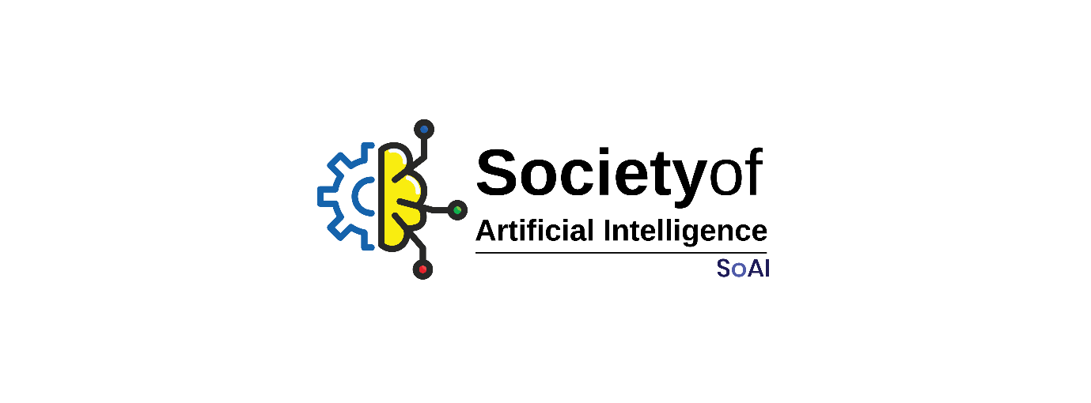

**LACK OF DATA**

We faced shortage of data as a major roadblock in our project. We scoured the internet for finding the data suitable for the YOLO model, as the YOLO model is more robust and General as compared to other approaches. We searched on the internet for the data for the YOLO algorithm, but could not find any such dataset. So we had to create our own dataset. Obviously it was taking too much time and we were able to collect only 1000 data points. We tried to train the YOLO model using that dataset and the results were terrible.

**TRYING COMPLEX ARCHITECTURES FIRST**

We faced quite a roadblock from trying to train YOLO model first without properly trying simple CNN model for classification. It took a lot of time to build the model, and then more time to train it. Then after that due to based data the performance was not that great. Then we tried the Simple CNN architecture, also we found a decent data on kaggle. Also it took less time to train and test. It performed quite well. Then after tuning it, it is the model we are using in our final project.

**LESSONS**

From this project, we learned a quite important that though the research papers might show that a particular complex model works well, but it is better to go step by step from simple models to complex ones especially if you do not have proper amount of data.